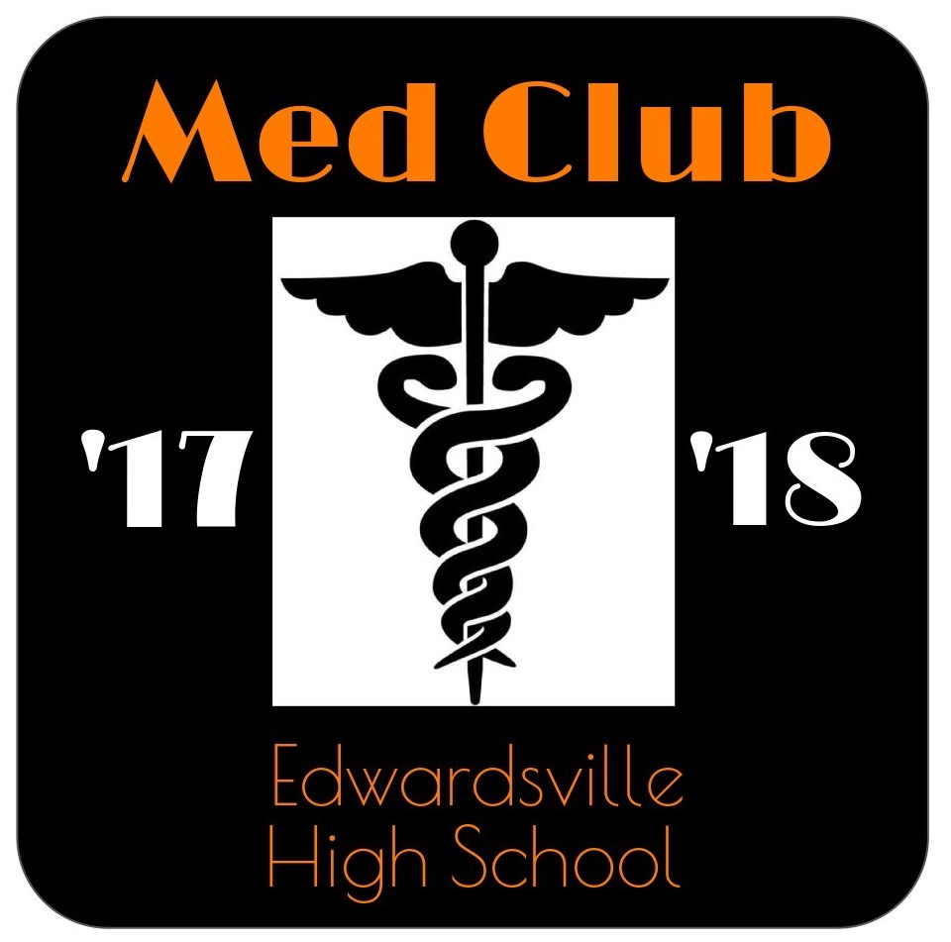
EHS MED CLUB CALENDAR

August
**Meetings begin August 28th
28th- Culver’s Night 5:30-7:30

September
11th- turn in dues and apps
B&L questionnaire
15th- Spirit Store opens
18th- vote for council
25th-Big’s & Little’s Reveal
TBD-Homecoming Float Decorating
*Buy t-shirts*

October
19th – 21st-Homecoming Window
4th-Homecoming Parade
5th-Homecoming Spirit Video
First Aid Kits

November
Bonding Party
Thanksgiving Baskets

December
Secret Santa
Adopt-a-Family

January
Princess Tea Party

February
HOSA Preparation

March
Feb. 28th—March 2nd-
HOSA State

April
NAMI/Cancer fundraiser

May
Blood Drive

June
HOSA Internationals

